Welcome! The purpose of this orientation is to introduce you to the new online format of the Active Living for Life exercise program and help you prepare for a safe and successful virtual workout.

# ABOUT THE PROGRAM

**The Active Living for Life (ALFL) program** was designed by experts in the fields of nephrology and exercise to help kidney patients like you become more active at home and in your community. The program has been developed by the **Kidney Foundation of Canada** with the help from students and staff from **Sheridan College** and supervised by Monika Dylewski, Registered Kinesiologist. The ALFL program is generously founded by the **Kazman Foundation for the Charitable Giving** and is offered FREE of charge to CKD patients and their support persons.

You will be participating in an ***Online*** version of this program, which was launched in response to the COVID-19 pandemic to help kidney patients increase their activity level at home and achieve their healthy lifestyle goals. The ALFL *Online* program is offered through Zoom for Healthcare as an underlying platform for communication and program delivery. To ensure successful participation you will be required to have a reliable internet connection and access to a computer or a tablet with a working video camera and a microphone.

The virtual exercise sessions will be offered **twice a week for 15 weeks**. You can choose to participate in one or both sessions. Each exercise session will be 45 minutes in length and will consist of a 5-minute warm up, followed by 30 minutes of strength and balance training and 10 minutes of cool down exercises. At the end of each session the participants will have an opportunity to ask questions and exchange comments. The program will be offered online at no cost and supervised by Monika Dylewski, Registered Kinesiologist. It will consist of two 45-minute sessions a week and will be offered for the period of 15 weeks. Each session will include a warmup, strengthening and balance exercises, and a cool down.

Every 3 weeks the exercise program will change to introduce new exercises and promote progress in strength and mobility. In addition to the two supervised workout sessions a week, you will be encouraged to complete a third session independently by logging into your account on the Embodia app in your own time and following the exercise videos for each program.

**Schedule:**

Currently, classes are scheduled on **Tuesday at 3 PM and Friday at 10 AM. Our next session will begin in September 2025.**

The classes are open to all and their caregiver if needed.

# EQUIPMENT

You will be expected to perform standing and/or sitting exercises with light to moderate resistance. If possible, we will try to modify the exercises to fit your needs. Some of the exercises could be also performed on a mat or lying in bed, but this is **OPTIONAL**.

**Here is a list of equipment choices for our workouts:**

* Elastic bands or tubing with or without handles
* Dumbbell weights:

Light: 2lb – 4lb, Medium: 5lb – 8lbs, Heavy: 10lb – 15lb

*Alternatives:* food cans, water bottles, jugs, buckets with handles, backpack filled with books

* Elastic loops (various tensions)

*Alternative*: elastic band tied up in a loop

* Chair

* Pillow

* Mat - optional

# REGISTRATION AND USING ONLINE PLATFORMS

Our mission is to:

• Provide you with various tools to help lead an active lifestyle in a safe and comfortable environment

• Provide support to help you overcome barriers that have stopped you from enjoying physical activity

• Help you find ways of becoming more active in your daily life

​

​The program will be offered online at no cost and supervised by Monika Dylewski, Registered Kinesiologist. It will consist of two 45-minute sessions a week and will be offered for the period of 15 weeks. Each session will include a warm up, strengthening and balance exercises, and a cool down.

To register, email us at [activelivingbrampton@gmail.com](mailto:activelivingbrampton@gmail.com) with your contact details

**ZOOM**

After your registration with the ALFLprogram is confirmed through email. We will send you a link that will allow you to join either session on Zoom. Please keep that link for the full 15 weeks.

**During the virtual class:**

* Access exercise session on Zoom a couple of minutes before the start time and wait for the instructor to admit you into the session
* Upon admission make sure your camera and microphone are turned ON
* Change your screen name to your FIRST NAME
* Adjust the camera angle on your device so that the instructor can SEE YOUR ENTIRE BODY • Click on 3 dots in the top right corner of the instructor’s screen and click “PIN TO SCREEN”. This will enlarge instructor’s screen and eliminate the gallery view, so you won’t see the other participants screens.
* Just before the exercises begin you will be asked to MUTE your microphone to eliminate the echo and noise
* You can ask questions OPENLY during class by un-muting yourself or PRIVATELY by typing them in a chat box or emailing them to: **activelivingbrampton@gmail.com**
* If you need to leave the session early, please notify the supervising instructor by un-muting yourself or typing a message in the chat box.

Please, test your device before starting the program to ensure that your desktop computer, laptop or a tablet has a working video camera and microphone and that the space you are planning to work out in is well visible. Download Zoom application on your device to make accessing virtual classes easier. Visit Zoom website and review its user guide or ask someone who knows this platform for help if you are unfamiliar with Zoom.

**Trouble-shooting:**

* On occasion, you may lose the video connection, your screen may freeze, or you might be disconnected from the session
* If you lose internet connection or Zoom session gets interrupted, we won’t unfortunately be able to assist you during class time
* Try to re-establish Wi-Fi connection, reset your router if needed, and click on the “Join the consult” button in the email to connect again or access the session through the browser
* If the class instructor loses internet connection or their video/audio gets interrupted, the monitoring instructor will take over the class momentarily, while the class instructor tries to reconnect to the session

# SAFETY AND EMERGENCY MEASURES

* Let someone in your household know that you are participating in the exercise class, so that they are available should you need help
* If you are exercising alone, we recommend having a plan in place to contact someone in case of emergency
* If you have any health concerns related to or as a result of your participation in exercises, please contact your physician and follow their recommendations.
* To ensure a safe workout arrange for a clear space and keep all equipment where you can see it.
* Wear running shoes and proper fitness attire. No tight jeans restricting movement or flip flops/ sandals or slippery socks. Shoes with good traction and support are the safest.
* Select appropriate exercise equipment.
* Exercise within your own limitations and at your own pace.
* Please have your video camera turned ON at ALL TIMES

**You should STOP exercising if:**

You feel very tired

You are short of breath

You feel chest pain

You feel irregular or rapid heart beats

You feel sick to your stomach

You get leg cramps

You feel dizzy or light-headed

**You should NOT exercise if:**

* You have a fever of 38 degrees Celsius or greater (100.5 F)
* You have changed your dialysis schedule
* You have changed your medicine schedule
* Your physical condition has changed
* You have been experiencing severe nausea and vomiting
* You have been experiencing shortness of breath at rest or with minimal effort
* You have been experiencing dizziness
* You have been feeling extreme fatigue
* You have severe anemia (low red blood cell count with Hemoglobin less than 80g/L)
* You have unrelieved pain
* You have joint or bone problems that become worse with exercise
* You have unsafe heart rate or blood pressure values (too high or too low)

**Clarify with your physician should you have any concerns regarding your participation in exercise.**

# UNDERSTANDING EXERCISE INTENSITY

Exercise intensity correlates with how hard the activity feels to you and is also reflected in:

* your breathing rate
* your heart rate
* whether you are sweating
* and how tired your muscles feel.

There are two basic ways to measure exercise intensity:

**First way is to assess How you feel.**

Exercise intensity is a subjective measure of how hard physical activity feels to you while you are doing it, which is your perceived exertion. Your perceived level of exertion may be different from what someone else feels doing the same exercise. For example, what feels to you like a very hard exercise can feel like an easy workout to someone who is more fit.

**The second method of measuring your exercise intensity is with the Heart Rate.**

The heart rate is based in numbers and offers a more objective look at exercise intensity.

In general, the higher your heart rate during physical activity, the higher the exercise intensity.

**Studies** show that your perceived exertion correlates well with your heart rate. So, if you think you're working hard, your heart rate is likely elevated to reflect that.

You can use either way of gauging exercise intensity.

# GAUGING INTENSITY BY HOW YOU FEEL

**Low exercise intensity:** activity feels light and very manageable; it requires a small effort. The signs that you are working at low intensity are:

* Breathing rate is slightly faster, but you can comfortably carry a conversation.
* You may or may not develop a light sweat after about 10 minutes of activity • You can work at this intensity for an extended time without feeling fatigued.

**Moderate exercise intensity:** activityfeels somewhat hard but still manageable. Here is how you can tell that you’re working at a moderate level:

* Your breathing quickens, but you're not out of breath.
* You develop a light sweat after about 10 minutes of activity and perhaps you start to feel some muscle fatigue.
* You can carry on a conversation, but you can't sing.

**High or Vigorous exercise intensity:** activity feels challenging and creates a feeling of significant fatigue within a few minutes.

Here are clues that your exercise intensity is at a vigorous level:

* Your breathing is deep and rapid.
* You develop a sweat after a few minutes of activity
* You can't say more than a few words without pausing for breath.

# THE MODIFIED BORG SCALE OF PERCEIVED EXERTION

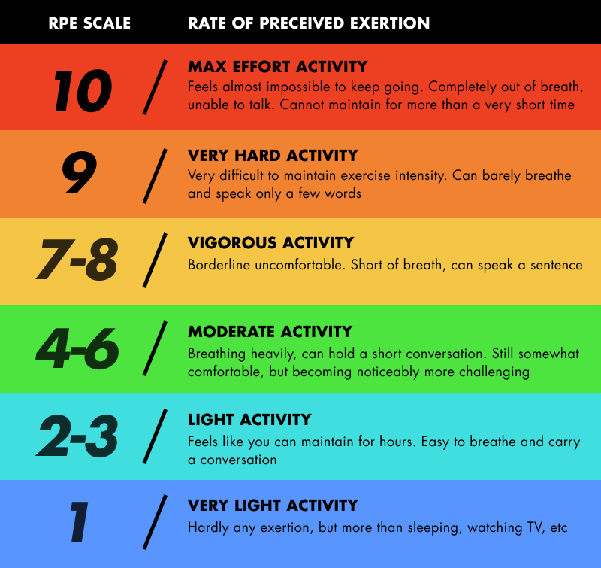Modified Borg scale is a helpful way to judge exercise intensity. It’s a scale from 1 to 10 where 1 is a very mild activity with hardly any exertion and 10 is a maximum exertion activity, where it feels almost impossible to keep going. To stay in the moderate intensity you should aim to be somewhere between 4 – 6 out of 10, occasionally pushing it to 7 if you like the challenge and feel good with it.

# GAUGING INTENSITY USING YOUR HEART RATE

Another way to gauge your exercise intensity is to see how hard your heart is beating during physical activity. To use this method, you first must figure out your ***maximum heart rate*** which is the upper limit of what your cardiovascular system can handle during physical activity.

The basic way to calculate your maximum heart rate is **to subtract your age from 220.**

For example, if you are 50 years old, subtract 50 from 220 to get a maximum heart rate of 170 bpm (beats per minute). Once you know your maximum heart rate, you can calculate your **desired target heart rate zone**. Target heart rate is the level at which your heart is being exercised and conditioned but not overworked.

**Here is how heart rate matches up with exercise intensity levels:**

* Light exercise intensity: 50 to 70 percent of your maximum heart rate
* Moderate exercise intensity: 60 to 80 percent of your maximum heart rate
* Vigorous exercise intensity: 70 to 85 percent of your maximum heart rate

# HOW TO DETERMINE YOUR MODERATE TARGET HEART RATE ZONE

* Subtract your **age from 220** to get your maximum heart rate.

* Multiple that number by **0.6 (60 percent)** to determine the lower end of your target heart rate zone.
* Multiply your maximum heart rate by **0.8 (80 percent)** to determine the upper end of your target heart rate zone.

* **Example: for a person who is 50 years old**

**220-50 = 170 bpm is the estimated max heart rate**

**170 x 0.6 = 102 bpm**

**170 x 0.8 = 136 bpm**

This person would want to work between 102-136 bpm to achieve moderate intensity exercise.

# HOW TO TELL IF YOU'RE IN THE ZONE

**So how do you know if you are in your target heart rate zone?**

* Stop the activity momentarily.
* Take your pulse for 15 seconds.

To check your pulse over your **carotid artery**, place your index and third fingers on your neck to the side of your windpipe.

To check your pulse **at your wrist**, place two fingers between the bone and the tendon over your **radial artery** — which is located on the thumb side of your wrist.

* Multiply this number by 4 to calculate your beats per minute.

**Here is an example:** You stop exercising and take your pulse for 15 seconds, getting 33 beats. Multiply 33 by 4, to get 132. If you are 50 years old, this puts you in the target heart rate zone for **moderate exercise**, since that zone is 102 to 136 beats per minute.

* If you are under or over your target heart rate zone, adjust your exercise intensity

* You can also use electronic devices such as FitBits, Smart Watches and portable Heart Rate Monitors to accurately read your heart rate

# TARGET HEART RATE TIPS

It is important to note that maximum heart rate is just a guide. You may have a higher or lower maximum heart rate, sometimes by as much as 15 to 20 beats per minute. Various medications and treatments such as **hemodialysis** may cause **a higher resting heart rate.**

Also, several types of medications can lower your maximum heart rate and, therefore, lower your target heart rate zone. An example of such a medication would be a **beta blocker** or a **calcium** or **sodium channel blocker**.

This is a time when rate of perceived exertion (how hard you feel you are working) can be a better strategy.

THANK YOU FOR REVIEWING THIS ORIENTATION DOCUMENT.

SHOULD YOU HAVE ANY FURTHER QUESTIONS, PLEASE E-MAIL US AT: **ACTIVELIVINGBRAMPTON@GMAIL.COM**

**SEE YOU SOON ONLINE!**